CSS BRITISH HISTORY · TOPIC 2 · KNOWLEDGE BASE
Hanoverian Britain, the Whig Oligarchy and the First Empire (1714–1783)
George I to Lord North — Walpole, the Jacobites, the Old Colonial System, Chatham's war, slavery and the loss of America

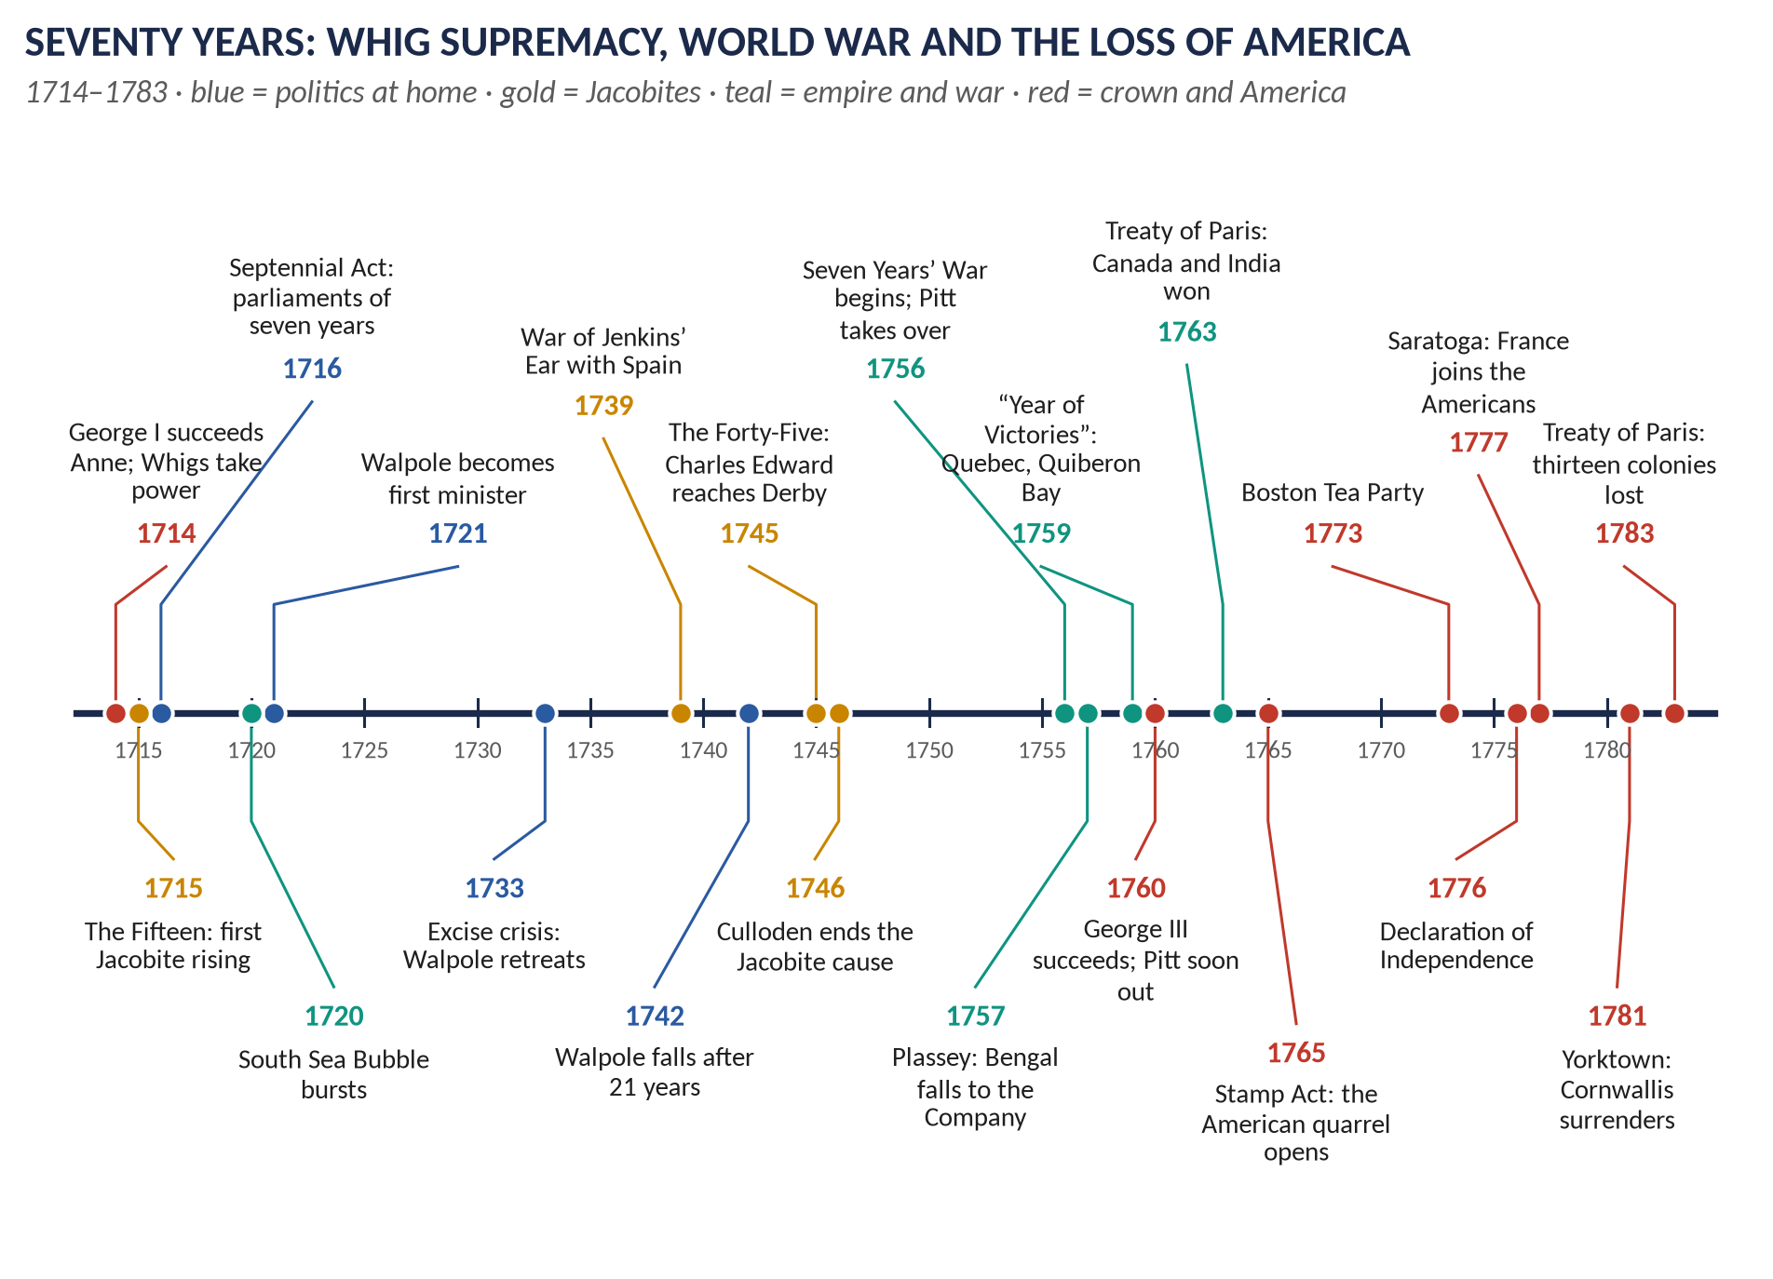
Syllabus heads II and V. Asked 8 times in 2015–2026 (Walpole and the Whig oligarchy three times) and 7 MCQs in 2024–26. The topic is told as a story first, then broken into seven chapters, and ends with 118 one-liners and a revision sheet that stands on its own.
Topic 2 of 10 · read with the companion document T2QA (every past question answered)
Contents
HOW TO USE THIS · Updating the contents
Right-click the contents → Update Field → Update entire table, before saving as PDF.

How to Use This Document 5
What this Topic covers 5
How this document is built 5
Part Zero — The ABC Before the Story 6
0.1 What was new in 1714 6
0.2 The words this topic needs 6
Part One — The Story 8
1.1 A German king and a Whig monopoly (1714–1721) 8
1.2 Walpole's twenty-one years (1721–1742) 8
1.3 The Forty-Five (1745–46) 9
1.4 The Old Colonial System and the slave trade 10
1.5 Pitt and the Seven Years' War (1756–1763) 11
1.6 George III, the King's Friends and the end of the oligarchy 12
1.7 Losing America (1763–1783) 12
Part Two — The Cast and the Time-line 14
2.1 The cast 14
2.2 The time-line 15
Part Three — The Chapters 17
Chapter 1 · The Hanoverian Succession and Its Significance 18
1.1 How the succession happened 18
1.2 Political significance 18
(i) A half-century of Whig rule 18
(ii) Jacobitism as the permanent alternative 18
(iii) The politics of management 18
1.3 Constitutional significance 18
(i) The crown becomes a parliamentary title 18
(ii) Cabinet government grows in the king's absence 19
(iii) A first minister emerges 19
(iv) Ministers must hold the Commons 19
(v) The Act of Settlement's restrictions 19
Chapter 2 · Walpole and the Whig Oligarchy 20
2.1 How the Whigs monopolised power 20
2.2 Walpole's four roles 20
(i) Minister of the Crown 20
(ii) Prime minister in the making 21
(iii) Party organiser 21
(iv) Financier 21
2.3 The merits of Whig rule 21
2.4 The demerits 22
2.5 Why the oligarchy fell 22
Chapter 3 · The Jacobites: 1715, 1745 and After 24
3.1 What Jacobitism was 24
3.2 The Fifteen 24
3.3 The Forty-Five 24
3.4 The aftermath 25
Significance 25
Chapter 4 · The Old Colonial System, Slavery and Abolition 26
4.1 What the Old Colonial System was 26
(i) The theory: mercantilism 26
(ii) The machinery: the Navigation Acts 26
(iii) The practice: salutary neglect 26
4.2 The Atlantic slave trade 26
4.3 Abolition — the campaign and the arguments 27
The historians' argument 27
4.4 Abolition and empire 27
Chapter 5 · Chatham and the Seven Years' War 29
5.1 Pitt the Elder before the war 29
5.2 The causes and course of the war 29
(i) Causes 29
(ii) The bad start and Pitt's rise 29
(iii) Pitt's strategy 29
(iv) The key actions (keyed to the map in Part One) 30
5.3 The Peace of Paris, 1763 30
5.4 "A glorious success until 1761 and then failure"? 30
The case for success to 1761 30
The case for failure after 1761 31
The verdict to offer 31
Chapter 6 · George III and the Politics of 1760–1783 32
6.1 The new king and his aims 32
6.2 Instability, 1760–1770 32
6.3 Wilkes and liberty 32
6.4 Economical reform and the end of the American war 33
Chapter 7 · The American War of Independence 34
7.1 The causes 34
(i) The consequences of victory (1763) 34
(ii) The tax quarrel 34
(iii) The deeper causes 35
7.2 The war 35
Why Britain lost 35
7.3 The results — the balance sheet for Britain 36
The debit side 36
The credit side 36
Part Four — Historians and Quotations 37
4.1 The historians 37
4.2 Lines worth quoting 37
Part Five — The Examiner's Record 38
Part Six — The One-Liner Bank 39
One-liners · The Hanoverian succession 39
One-liners · Walpole and the Whig oligarchy 39
One-liners · The Jacobites 40
One-liners · The Old Colonial System and slavery 41
One-liners · Chatham and the Seven Years' War 42
One-liners · George III and the American war 43
Part Seven — Revision Sheet · Topic 2: Hanoverian Britain, the Whig Oligarchy and the First Empire, 1714–1783 45
R2.1 The story in ten lines 45
R2.2 The Hanoverian succession — political and constitutional significance 46
R2.3 Walpole in four roles 46
R2.4 The Whig oligarchy: merits, demerits, downfall 46
R2.5 The Jacobites 46
R2.6 The Old Colonial System, slavery and abolition 47
R2.7 Chatham and the Seven Years' War 47
R2.8 Why Britain lost America — and the balance sheet 47
R2.9 Ten dates to write in every answer 48

How to Use This Document

What this Topic covers
This is Topic 2 of ten. It covers the seventy years from the accession of George I in 1714 to the Treaty of Paris of 1783: the Hanoverian succession, the Jacobite risings of 1715 and 1745, Robert Walpole and the Whig oligarchy, the Old Colonial System and the Atlantic slave trade, Pitt the Elder and the Seven Years' War, the reign of George III, and the American War of Independence. It covers syllabus Head II (the Hanoverian era) and Head V (the Old Colonial System).
WHAT THE EXAMINER HAS ASKED · Why this topic matters
Eight descriptive items in 2015–2026: Walpole (2015), the Whig oligarchy twice in nearly the same words (2017, 2020), the Hanoverian succession (2019), Chatham (2022), the American War (2015), abolition and empire (2026) and a short note on the Jacobite Revolt (2015). Plus 7 MCQs in the last three papers. The record is in Part Five.

THE STORY IN SIMPLE WORDS · The story so far — where Topic 1 left us
In 1714 Queen Anne died childless. Under the Act of Settlement of 1701 the crown passed over fifty Catholic claimants to the Protestant House of Hanover. The Revolution Settlement of 1689–1701 had already made the monarch govern with Parliament; England and Scotland had become Great Britain in 1707; and the wars against Louis XIV had left Britain a great power with Gibraltar, Minorca and the asiento. The exiled Stuarts, however, had not given up.

How this document is built
1. Part Zero — The ABC. What had changed by 1714, and the words this topic needs.
2. Part One — The Story. The whole topic told simply. Read it twice before anything else.
3. Part Two — The Cast and the Time-line.
4. Part Three — The Chapters. Seven chapters with maps, flow diagrams and tables.
5. Part Four — Historians and Quotations.
6. Part Five — The Examiner's Record.
7. Part Six — The One-Liner Bank. 118 one-line questions and answers.
8. Part Seven — The Revision Sheet, complete on its own.

Part Zero — The ABC Before the Story

0.1 What was new in 1714
The change | What it meant in practice
A foreign king | George I was 54, German-speaking, Elector of Hanover, and spent about a fifth of his reign abroad. He left much business to ministers.
A parliamentary title | He was king by Act of Parliament, not by hereditary right — the Stuart line had a better hereditary claim.
Party war | Whigs (for the Revolution, the Hanoverians, the Dissenters and the war) against Tories (for the Church, the land and peace). After 1714 the Tories were suspected of Jacobitism.
A new fiscal state | The Bank of England (1694), the National Debt and taxes voted yearly by Parliament let Britain borrow cheaply and fight long wars.
An empire of trade | Colonies in North America and the Caribbean, forts in West Africa and India, run on mercantilist principles.
Great Britain | England and Scotland had been one kingdom since 1707; Ireland was a separate kingdom with its own (Protestant) Parliament, subordinate to London.

0.2 The words this topic needs
Word | Meaning
Whig oligarchy / Whig supremacy | The rule of a small group of great Whig families, 1714–1760, when the Tories were shut out of office.
Patronage | The gift of jobs, pensions, contracts and church livings, used to build a majority in Parliament.
Placeman | An MP who held a paid office under the Crown and therefore voted with the government.
Rotten borough | A constituency with very few voters that still returned MPs. A pocket borough was one controlled by a single patron.
Prime minister | The leading minister. The title began as an insult; Walpole (1721–42) is counted the first.
Cabinet | The inner group of ministers who decided policy — increasingly without the king present.
Jacobite | A supporter of the exiled Stuarts (Latin Jacobus, James). Their risings were the Fifteen and the Forty-Five.
The Pretenders | James Francis Edward, the "Old Pretender" (1688–1766), and his son Charles Edward, the "Young Pretender" or "Bonnie Prince Charlie" (1720–88).
Mercantilism | The belief that a nation's wealth is a fixed stock of bullion and trade, so colonies exist to enrich the mother country.
Old Colonial System | The whole structure of mercantilist rules — the Navigation Acts, colonial monopolies and the slave trade — that governed the first British Empire.
Navigation Acts | Laws (from 1651) confining colonial trade to British ships and routing "enumerated" goods through British ports.
Triangular trade | Manufactures from Britain to West Africa; enslaved Africans across the Middle Passage to the Americas; sugar, tobacco and cotton home.
Salutary neglect | The loose enforcement of the trade laws before 1763, which let the colonies govern and tax themselves in practice.
No taxation without representation | The colonists' claim that only their own assemblies, not a Parliament they did not elect, could tax them.
Virtual representation | The British reply: MPs represent the whole empire, not just those who elect them.
Seven Years' War | The world war of 1756–1763, called in America the French and Indian War; ended by the Treaty of Paris.
The King's Friends | MPs who supported George III's chosen ministers after 1760, breaking the Whig monopoly.
Abolition | The ending of the slave trade (1807) and then of slavery in the British Empire (1833–34).

Part One — The Story
THE STORY IN SIMPLE WORDS · Read this Part first, straight through
Every name and date here returns, with detail, in Part Three.

1.1 A German king and a Whig monopoly (1714–1721)
On 1 August 1714 Queen Anne died, and George, Elector of Hanover, became King George I. The transfer was quiet; the Tory minister Bolingbroke, who had been in touch with the exiled Stuarts, fled to France.
George blamed the Tories for the Peace of Utrecht and for flirting with the Pretender, so he gave office to the Whigs. It was a decision that shaped fifty years: the Tories were proscribed — shut out of government — until 1760.
The exiled Stuarts struck at once. In 1715 the Earl of Mar raised the Jacobite standard in Scotland for James Francis Edward, the "Old Pretender". The rising was badly led, fought an indecisive battle at Sheriffmuir, and collapsed; James arrived too late and left within weeks.
The Whigs then made their position permanent with the Septennial Act (1716), which stretched the life of a Parliament from three years to seven. Fewer elections meant a majority that could be managed.
In 1720 came the crash. The South Sea Company had offered to take over the National Debt; its shares rose from about £128 to over £1,000 and then collapsed, ruining thousands and touching ministers and the royal family. The man who cleaned up the mess — protecting the government and the Crown, and earning the nickname the "Screen-Master General" — became the dominant figure in politics: Sir Robert Walpole.

1.2 Walpole's twenty-one years (1721–1742)
Walpole took office in 1721 as First Lord of the Treasury and Chancellor of the Exchequer, and stayed for twenty-one years — still the longest premiership in British history.
His method had three parts. First, he stayed in the House of Commons, where money was voted, when other great ministers took peerages. Second, he managed the king: George I, then George II from 1727, and above all Queen Caroline, who was George II's most trusted adviser. Third, he used patronage — jobs, pensions, contracts, church livings — to hold a majority together.
His policy was peace and low taxes: "let sleeping dogs lie". He kept Britain out of the war of the Polish Succession (1733–35), cut the land tax to 1s in the pound, and reduced the debt through a sinking fund. His one great defeat came in 1733, when his excise scheme — a sensible reform of customs duties — produced such an outcry ("no slavery, no excise, no wooden shoes") that he withdrew it.
Walpole's critics called his system the "Robinocracy" and mocked him in The Craftsman, in Gay's Beggar's Opera and in Swift's satires. In 1739 popular pressure — and the tale of Captain Jenkins, who displayed an ear cut off by Spanish coastguards — forced him into the War of Jenkins' Ear. He ran it without enthusiasm and fell in 1742 when his majority dissolved.

1.3 The Forty-Five (1745–46)
The last and most dangerous Jacobite rising came in 1745, while Britain was fighting the War of the Austrian Succession. Charles Edward Stuart, the "Young Pretender", landed in the Hebrides with seven companions and raised his standard at Glenfinnan in August.
He took Edinburgh, beat a government army at Prestonpans (September), and marched south. On 5 December 1745 the Jacobite army reached Derby, about 130 miles from London — close enough to cause panic in the capital ("Black Friday") and a run on the Bank of England. But the promised English and French support had not appeared, and the chiefs voted to retreat.
The retreat ended on 16 April 1746 at Culloden, near Inverness, where the Duke of Cumberland destroyed the Highland army in under an hour. The repression that followed — executions, the Act of Proscription (1746) banning Highland dress and disarming the clans, and the abolition of heritable jurisdictions (1747) — ended the clan system and the Stuart cause together. Charles Edward escaped to France after five months as a fugitive and died a disappointed man in 1788.
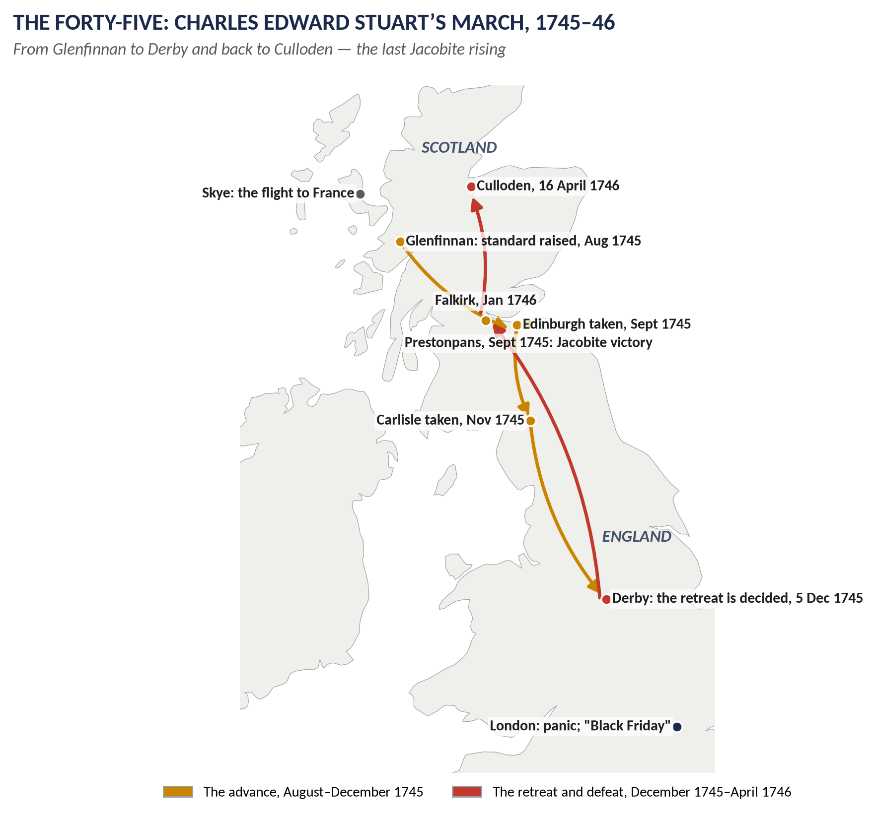
Figure 1 · The Forty-Five: the march from Glenfinnan to Derby, and the retreat to Culloden.

1.4 The Old Colonial System and the slave trade
While politics at home was quiet, Britain's empire of trade grew fast. Its rules were mercantilist: the Navigation Acts required colonial trade to travel in British ships, and "enumerated" goods — sugar, tobacco, cotton, indigo — to pass through British ports.
At the centre of this system was the Atlantic slave trade. British ships carried manufactures to West Africa, enslaved Africans across the Middle Passage to the Caribbean and the American South, and sugar, tobacco and rum home to Bristol, Liverpool and London. Over the whole period British ships carried about 3.1 million Africans; perhaps 400,000 died at sea. The asiento won at Utrecht (1713) added the Spanish American market.
The system was enforced loosely. Colonial assemblies voted their own taxes and ran their own affairs; smuggling was normal. Edmund Burke later called this "salutary neglect" — and argued that abandoning it caused the American crisis.
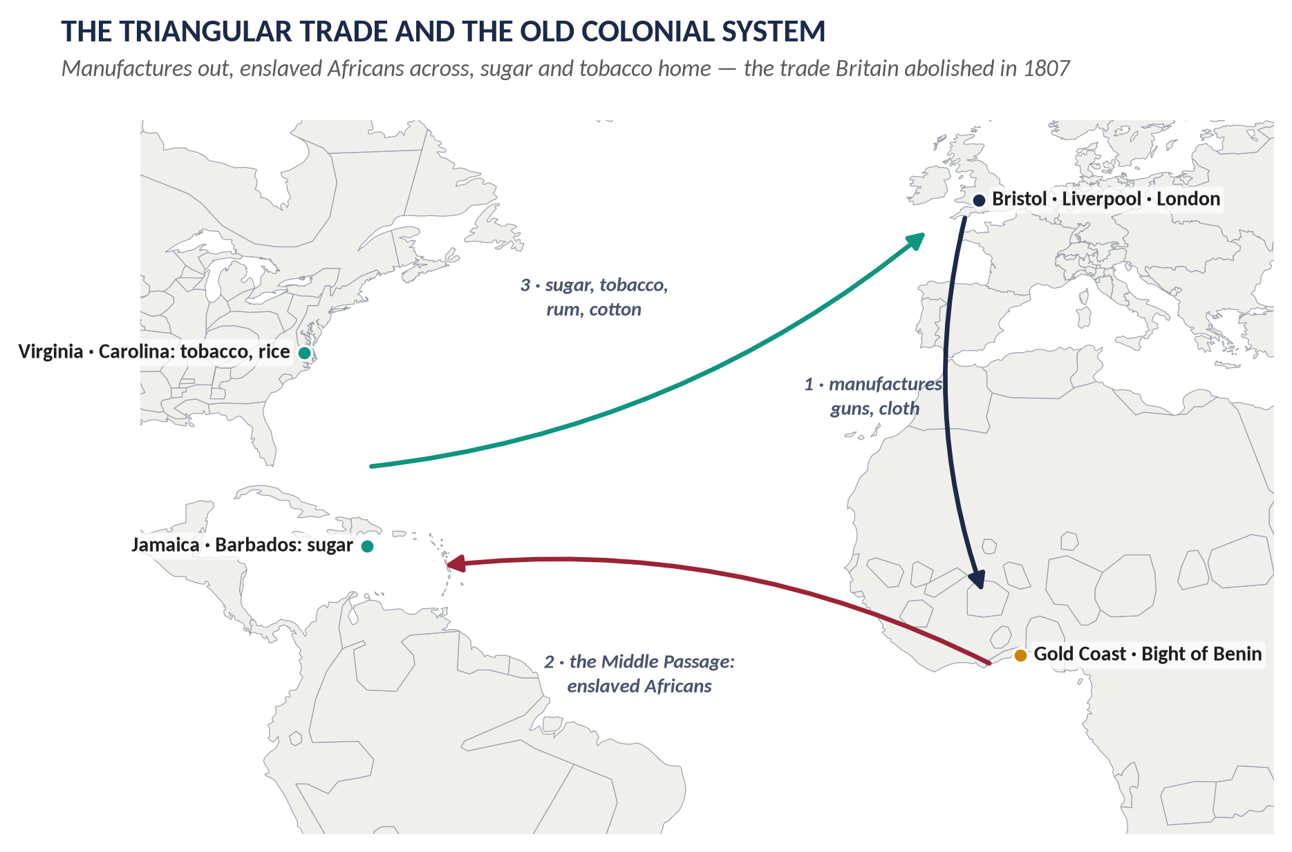
Figure 2 · The triangular trade: the engine of the first British Empire.

1.5 Pitt and the Seven Years' War (1756–1763)
The Seven Years' War was the first true world war, fought in Europe, North America, the Caribbean, West Africa, India and the Philippines. It began badly for Britain: Minorca was lost in 1756 and Admiral Byng was shot for failing to relieve it.
Then William Pitt the Elder took charge of the war effort (from 1757, with the Duke of Newcastle managing Parliament and finance). Pitt's strategy was simple and expensive: subsidise Prussia under Frederick the Great to tie down the French in Europe, and use the navy to take French colonies and trade.
It worked spectacularly. 1759 was the "Year of Victories": Quebec (where both Wolfe and Montcalm died), Minden, Lagos and Quiberon Bay. In India, Robert Clive had already won Plassey (1757), which made the East India Company the real power in Bengal. By 1762 Britain had taken Havana and Manila from Spain.
The Treaty of Paris (1763) gave Britain Canada, Florida, the lands east of the Mississippi, Senegal and most of France's Indian trading posts. Britain was now the world's leading colonial and naval power — with a National Debt doubled to about £133 million.
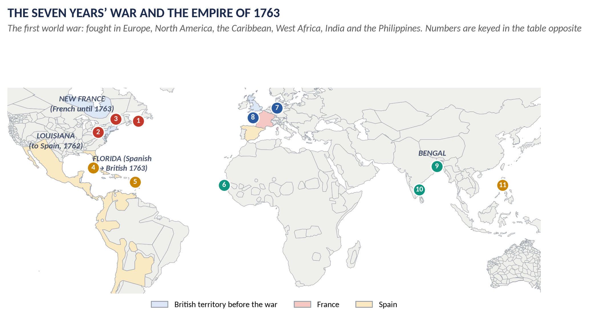
Figure 3 · The Seven Years' War, 1756–63, and the empire it created. The numbers are keyed in Chapter 5.

1.6 George III, the King's Friends and the end of the oligarchy
George III came to the throne in 1760 at twenty-two. Unlike his great-grandfather and grandfather he was British-born — "I glory in the name of Briton" — and he meant to be a king who chose his own ministers rather than accept whichever Whig combination presented itself.
He ended the proscription of the Tories, made his old tutor Lord Bute prime minister in 1762, and built up a group of supporters known as the "King's Friends". Pitt resigned in 1761 when the cabinet refused to attack Spain; Newcastle followed in 1762.
The Whig monopoly dissolved into competing factions — Rockingham, Grenville, Bedford, Chatham. Between 1760 and 1770 there were seven ministries. Meanwhile the radical John Wilkes — expelled from the Commons, prosecuted for North Briton No. 45, elected repeatedly for Middlesex and repeatedly disqualified — turned "Wilkes and Liberty" into the first great popular political movement since the Revolution. Stability returned only when Lord North became prime minister in 1770 — just in time for the American crisis.

1.7 Losing America (1763–1783)
Victory created the problem. With France expelled from Canada, the colonies no longer needed British protection; and someone had to pay for the war and for the 10,000 troops now stationed in America.
Parliament's answer was taxation: the Sugar Act (1764) and then the Stamp Act (1765), a duty on every legal document, newspaper and pack of cards. The colonies erupted. The Stamp Act was repealed in 1766 — but accompanied by the Declaratory Act, which asserted Parliament's right to legislate for the colonies "in all cases whatsoever". The Townshend duties (1767), the Boston Massacre (1770), the Boston Tea Party (16 December 1773) and the Coercive Acts (1774) followed.
Fighting began at Lexington and Concord in April 1775. On 4 July 1776 Congress adopted the Declaration of Independence. The turning point came at Saratoga (1777), where Burgoyne's army surrendered; the defeat persuaded France to enter the war in 1778, followed by Spain (1779) and the Dutch (1780), while the League of Armed Neutrality closed off Britain's friends. For the first time Britain fought without an ally and lost command of the sea at the critical moment. At Yorktown (19 October 1781) a French fleet cut off Cornwallis, who surrendered his army.
North's ministry fell in 1782 and the Treaty of Paris (1783) recognised the independence of the United States. Britain kept Canada, the West Indies, Gibraltar and India.
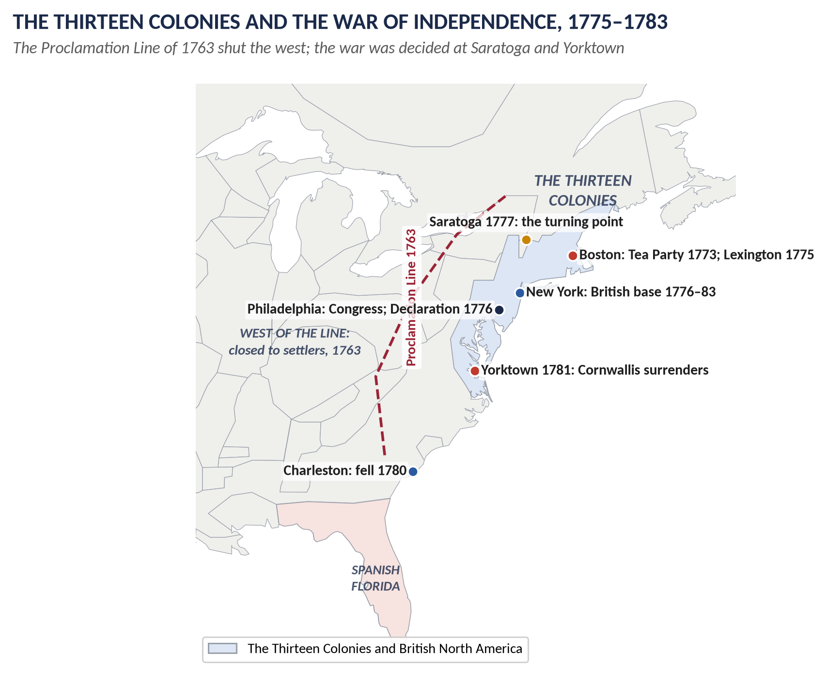
Figure 4 · The Thirteen Colonies, the Proclamation Line of 1763, and the war that lost them.
VERDICT · The story in one sentence
Between 1714 and 1783 Britain gained a German dynasty, half a century of one-party Whig rule, the greatest colonial empire in the world — and then lost the most valuable part of it, because the victory of 1763 removed the fear that had held the colonies to the mother country and left a debt that Parliament tried to make them pay.

Part Two — The Cast and the Time-line

2.1 The cast
Person | Dates | Who they were — in one line
George I | 1660–1727; king 1714–27 | Elector of Hanover; first Hanoverian king; left much to his ministers.
George II | 1683–1760; king 1727–60 | Last British king to lead troops in battle (Dettingen, 1743).
Queen Caroline | 1683–1737 | George II's wife; Walpole's indispensable ally at court.
George III | 1738–1820; king 1760–1820 | British-born; ended the Whig monopoly; lost America.
Sir Robert Walpole | 1676–1745; in office 1721–42 | The first prime minister; peace, low taxes and patronage.
Viscount Townshend | 1674–1738 | Walpole's brother-in-law and colleague, forced out in 1730.
Duke of Newcastle | 1693–1768 | The great manager of elections and patronage; PM 1754–56, 1757–62.
William Pitt the Elder (Earl of Chatham) | 1708–78 | The "Great Commoner"; war minister 1756–61; PM 1766–68.
Lord Bute | 1713–92; PM 1762–63 | George III's tutor and first chief minister; made the Peace of Paris.
George Grenville | 1712–70; PM 1763–65 | Passed the Stamp Act.
Marquess of Rockingham | 1730–82 | Whig leader; repealed the Stamp Act (1766); PM again in 1782.
Lord North | 1732–92; PM 1770–82 | Presided over the loss of America.
John Wilkes | 1725–97 | Radical journalist and MP; "Wilkes and Liberty".
Edmund Burke | 1729–97 | Rockinghamite MP and political thinker; defended conciliation with America.
James Francis Edward Stuart | 1688–1766 | The "Old Pretender"; figurehead of the Fifteen.
Charles Edward Stuart | 1720–88 | The "Young Pretender"; led the Forty-Five.
Duke of Cumberland | 1721–65 | George II's son; victor of Culloden; "Butcher" to the Highlands.
Robert Clive | 1725–74 | Won Plassey (1757); founder of British power in Bengal.
James Wolfe | 1727–59 | Took Quebec and died there.
William Wilberforce | 1759–1833 | Led the parliamentary campaign against the slave trade.
Olaudah Equiano | c.1745–97 | Formerly enslaved author whose Interesting Narrative (1789) shaped opinion.
Lord Cornwallis | 1738–1805 | Surrendered at Yorktown (1781); later Governor-General of India.

2.2 The time-line
Figure 5 · Seventy years from the Hanoverian succession to the loss of America.
Date | Event
1714 | Death of Anne; George I succeeds; Whigs take office; Bolingbroke flees
1715 | The Fifteen: Mar's rising; Sheriffmuir; collapse
1716 | Septennial Act — seven-year parliaments
1720 | South Sea Bubble
1721 | Walpole becomes First Lord of the Treasury
1727 | George I dies; George II succeeds; Walpole survives
1733 | Excise crisis — the scheme withdrawn
1739 | War of Jenkins' Ear with Spain
1740–48 | War of the Austrian Succession; Dettingen (1743), Fontenoy (1745)
1742 | Walpole resigns after 21 years
1745–46 | The Forty-Five: Glenfinnan, Prestonpans, Derby (5 Dec), Culloden (16 Apr 1746)
1746–47 | Act of Proscription; heritable jurisdictions abolished
1756 | Seven Years' War begins; Minorca lost; Byng shot (1757)
1757 | Plassey; Pitt–Newcastle ministry formed
1759 | Year of Victories: Quebec, Minden, Lagos, Quiberon Bay
1760 | George III succeeds
1761 | Pitt resigns over war with Spain
1762–63 | Bute prime minister; Havana and Manila taken
1763 | Treaty of Paris; Proclamation Line; Wilkes and North Briton No. 45
1764–65 | Sugar Act; Stamp Act
1766 | Stamp Act repealed; Declaratory Act
1767 | Townshend duties
1770 | Lord North prime minister; Boston Massacre
1773 | Boston Tea Party (16 December)
1774 | Coercive (Intolerable) Acts; First Continental Congress
1775 | Lexington and Concord (April); Bunker Hill
1776 | Declaration of Independence (4 July); Adam Smith's Wealth of Nations
1777 | Saratoga
1778–80 | France, then Spain and the Dutch, enter the war
1781 | Yorktown (19 October)
1782 | North falls; Rockingham ministry; Irish legislative independence
1783 | Treaty of Paris; Pitt the Younger becomes prime minister (December)
1787–1807 | Abolition campaign → slave trade abolished 1807; slavery abolished 1833

Part Three — The Chapters

Chapter 1 · The Hanoverian Succession and Its Significance

1.1 How the succession happened
- The Act of Settlement (1701) gave the crown, after Anne, to Sophia of Hanover — a granddaughter of James I — and her Protestant heirs, passing over more than fifty Catholics with better hereditary claims.
- Sophia died in June 1714, weeks before Anne; so the crown went to her son, George Louis, Elector of Hanover.
- The Regency Act (1706) had prepared the machinery: named Lords Justices governed until the new king arrived. The transfer in August 1714 was therefore orderly.
- Bolingbroke, the Tory Secretary of State who had been negotiating with the Pretender, was dismissed and fled to France in 1715, confirming Tory guilt in Whig eyes.

1.2 Political significance

(i) A half-century of Whig rule
George I owed his crown to the Whigs, who had made the Act of Settlement and supported the war the Tories had ended. He gave them office — and for forty-six years (1714–60) the Tories were proscribed: excluded from the ministry, the court, the bench and the lord-lieutenancies.

(ii) Jacobitism as the permanent alternative
Because the Stuarts had the better hereditary claim, every Hanoverian government faced a rival court in exile. The risings of 1715 and 1745, and the French-backed attempts of 1708 and 1759, kept the question alive until Culloden.

(iii) The politics of management
With the Tories out, politics became a contest within the Whig party — between connections and families rather than parties. Namier argued that eighteenth-century politics is best understood as a structure of interest, patronage and family, not of ideology.

1.3 Constitutional significance

(i) The crown becomes a parliamentary title
George I was king because Parliament said so. After 1714 no serious person in England argued for divine, indefeasible hereditary right: the doctrine survived only among Non-Jurors and Jacobites. This completed what 1689 had begun.

(ii) Cabinet government grows in the king's absence
George I spent long periods in Hanover, did not speak fluent English and gradually stopped attending cabinet meetings. Ministers therefore met, decided and then reported. What began as convenience became convention: a cabinet that deliberates on its own and presents advice.

(iii) A first minister emerges
Someone had to speak for the cabinet in the Commons and to the king. From 1721 that man was Walpole. The office was not created by law and had no salary or title; it grew because the system needed it.

(iv) Ministers must hold the Commons
Walpole resigned in 1742 not because the king dismissed him but because he could no longer command a majority. That is the essential principle of modern British government, established by practice.

(v) The Act of Settlement's restrictions
The Act tied the new dynasty to Britain: the monarch must be Anglican; Britain must not be committed to war for the monarch's foreign territories without Parliament's consent; judges hold office during good behaviour.
TRAP — DO NOT FALL INTO IT · Do not exaggerate
The Crown was still powerful. It chose ministers, controlled patronage, made war and peace, and could destroy a ministry by withdrawing support. George III demonstrated all of this after 1760. The change from 1714 to 1783 was one of practice and balance, not of law.

WHAT THE EXAMINER HAS ASKED · Where Chapter 1 has been asked
2019 Q3: "What was the political and constitutional significance of the Hanoverian succession in England?" — answered in full in T2QA.

Chapter 2 · Walpole and the Whig Oligarchy
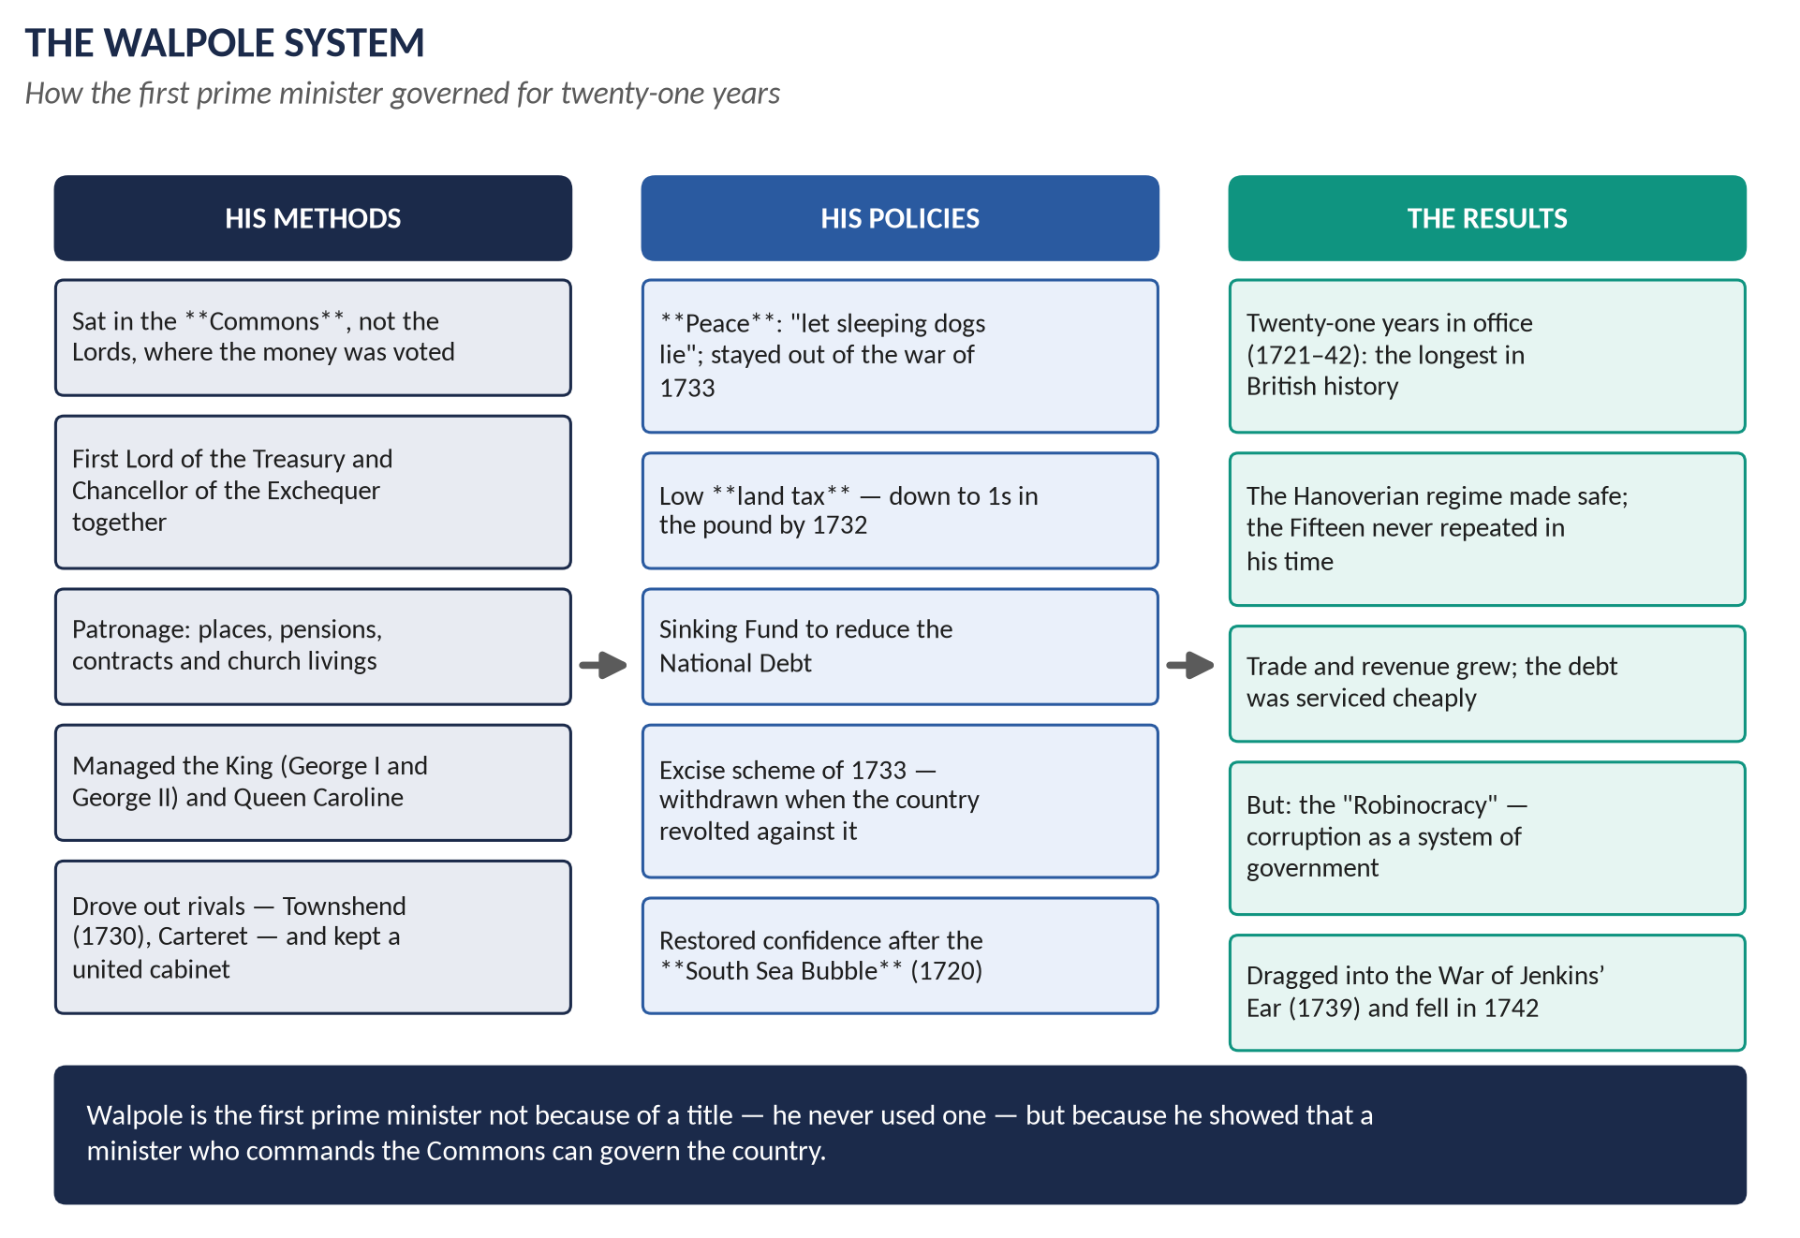
Figure 6 · The Walpole system: methods, policies and results.

2.1 How the Whigs monopolised power
1. The Tory taint of Jacobitism (1714–15): Bolingbroke's flight and the Fifteen made "Tory" and "Jacobite" look like the same thing.
2. The Septennial Act (1716): seven-year parliaments meant fewer elections, greater stability — and a majority that patronage could hold together.
3. The South Sea Bubble (1720): the crash discredited rivals and brought Walpole to the top as the man who saved the system.
4. Control of patronage: the Treasury, the Admiralty, the Church and the army all had places to give.
5. A narrow electorate: perhaps one adult man in five could vote in England, in constituencies that had not been redrawn since the Middle Ages.

2.2 Walpole's four roles

(i) Minister of the Crown
- Secretary at War (1708), Treasurer of the Navy; imprisoned in the Tower by the Tories in 1712 — which made him a Whig martyr.
- From 1721: First Lord of the Treasury and Chancellor of the Exchequer — money and management in one pair of hands.
- Kept the confidence of George I, then of George II through Queen Caroline.

(ii) Prime minister in the making
- Refused a peerage and stayed in the Commons: the first great minister to see that the Commons was now where power lay.
- Insisted on cabinet unity, forcing out Townshend (1730) and Carteret.
- Received 10 Downing Street from George II in 1735 — as an office for the First Lord of the Treasury, not a personal gift.
- Resigned in 1742 on losing his majority.

(iii) Party organiser
- Systematic use of places, pensions, sinecures, contracts and church livings.
- Managed elections through the Treasury and great borough-owning families.
- Kept the Tories out by identifying them with Jacobitism.

(iv) Financier
- Restored confidence after the South Sea Bubble, protecting the Crown and ministers — the "Screen-Master General".
- Revived the sinking fund to pay off debt; kept interest rates low.
- Reduced the land tax to 1s in the pound by 1732 — the tax paid by the gentry who sat in Parliament.
- The excise scheme of 1733: a sound plan to replace customs duties on wine and tobacco with excise, defeated by a storm of propaganda about "excisemen" and lost liberty. He withdrew it, saying he would not be the minister to "enforce taxes at the expense of blood".

2.3 The merits of Whig rule
Merit | Evidence
Political stability | After a century of civil war, revolution and disputed succession, Britain had fifty years without one
Peace and prosperity | Walpole kept out of European war 1721–39; trade, shipping and revenue grew steadily
The Revolution Settlement secured | The Protestant succession survived two risings; no serious attempt to restore prerogative rule
Constitutional development | Cabinet government and the office of prime minister took shape
Practical toleration | Dissenters protected by annual Indemnity Acts; a free press; no political executions after 1746

2.4 The demerits
Demerit | Evidence
Corruption as a system | Places and pensions for MPs; the "Robinocracy"; elections bought
An unrepresentative Parliament | Rotten and pocket boroughs; Old Sarum's handful of voters; the new industrial towns unrepresented
Oligarchy | Government by a few great families — the "Venetian oligarchy", as Disraeli later called it
No real opposition | Tories proscribed for two generations; opposition reduced to the "Patriot" faction around Frederick, Prince of Wales
Complacency | No reform of Parliament, the law, the Church, the poor law, Ireland or colonial government

2.5 Why the oligarchy fell
1. George III (1760): a British-born king determined to choose his own ministers; he ended the proscription of the Tories and built the "King's Friends".
2. Bute's ministry (1762): the Whig monopoly of office broken; the older Whigs found themselves in opposition.
3. Factionalism: with no common enemy, the Whigs split into Rockingham, Grenville, Bedford and Chatham connections — seven ministries in ten years.
4. New political forces: Wilkes and the Middlesex elections, the popular press, petitions, and the demand for "economical reform".
5. The American crisis: the system had no answer to an imperial problem that required imagination rather than management.
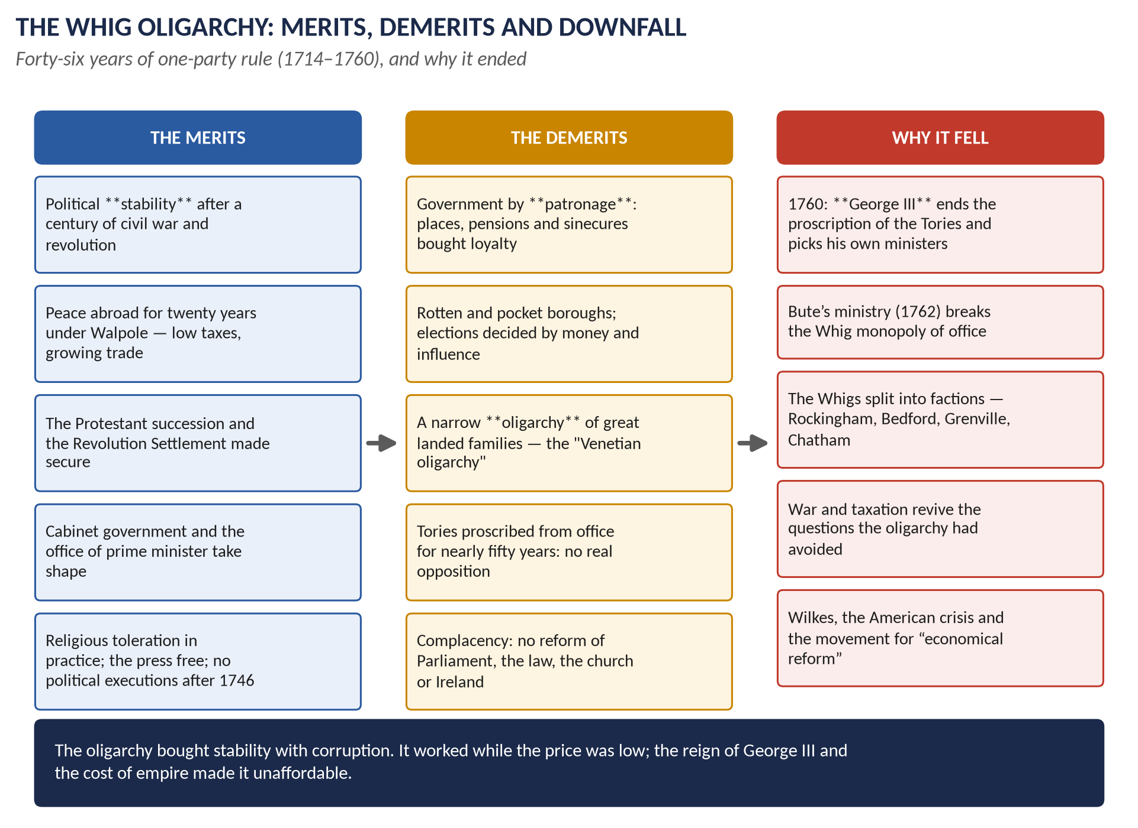
Figure 7 · The Whig oligarchy: merits, demerits and downfall.
WHAT THE EXAMINER HAS ASKED · Where Chapter 2 has been asked
2015 P1 Q4 (Walpole in four roles) · 2017 Q2 and 2020 Q2 (merits and demerits of Whig rule and the causes of its downfall — nearly the same wording). All answered in T2QA. MCQ 2024: the longest-serving Prime Minister is Walpole.

Chapter 3 · The Jacobites: 1715, 1745 and After

3.1 What Jacobitism was
- Loyalty to the exiled Stuarts: James II (d. 1701), his son James Francis Edward (the Old Pretender) and grandson Charles Edward (the Young Pretender).
- Its core was dynastic and constitutional — the belief that the rightful king had been unlawfully deposed in 1688 — but it drew strength from other loyalties: Catholicism in Ireland and parts of the Highlands, Episcopalianism in north-east Scotland, anti-Union feeling after 1707, and French strategic interest.
TRAP — DO NOT FALL INTO IT · The 2025 MCQ trap
Asked for the "primary cause" of the Jacobite rebellions with the options religion, economics, nationalism, the keyed answer was "None of these": the central issue was the Stuart dynastic claim, though religion was tangled up with it.

3.2 The Fifteen
- Cause: the Hanoverian succession (1714), Tory proscription and Bolingbroke's flight.
- Course: the Earl of Mar raised the standard at Braemar (September 1715) and gathered perhaps 10,000 men — more than in 1745. The indecisive Sheriffmuir (13 November) and the surrender at Preston (14 November) ended the hope. James landed at Peterhead in December, found a collapsing army, and left in February 1716.
- Why it failed: poor leadership, no French help (Louis XIV had died in 1715), and the government's control of the Lowlands and of Edinburgh Castle.

3.3 The Forty-Five
- Cause and opportunity: Britain was at war (the Austrian Succession), its army was in Flanders, and a French invasion had been planned in 1744.
- Course: Charles Edward landed with the "Seven Men of Moidart" and raised his standard at Glenfinnan (19 August 1745) → took Edinburgh (September) → won Prestonpans (21 September) → invaded England, took Carlisle → reached Derby (5 December) → retreated → won Falkirk (January 1746) → destroyed at Culloden (16 April 1746) by the Duke of Cumberland.
- Why Derby was the turning point: no English Jacobite rising, no French landing, three government armies converging, and only about 5,000 men. The chiefs voted to retreat against Charles's wishes.
- Why it failed: narrow social base (largely Highland, Episcopalian and Catholic); the Lowlands and England stayed loyal; command of the sea; and the financial strength of the state.

3.4 The aftermath
Measure | Effect
Executions and transportation | About 120 executed, including Lord Lovat (the last peer beheaded in Britain, 1747); around 1,000 transported
Act of Proscription (1746) | Banned Highland dress and the carrying of arms (repealed 1782)
Heritable Jurisdictions Act (1747) | Abolished the chiefs' private courts — the legal end of the clan system
Forfeited estates | Annexed to the Crown and managed for "civilising" improvement
Roads and forts | Continued Wade's military roads; Fort George built near Inverness

Significance
1. The dynasty was safe: no serious challenge to the Hanoverians afterwards.
2. The Highlands were transformed: the clan system ended; emigration and later the Clearances followed; within a generation Highland regiments were the shock troops of the empire.
3. Britain could now look outward: with the Jacobite threat gone, the state could concentrate on the imperial struggle with France.
WHAT THE EXAMINER HAS ASKED · Where Chapter 3 has been asked
2015 P1 Q8(c): short note on the Jacobite Revolt of Scotland — answered in T2QA. MCQ 2025: the primary cause of the Jacobite rebellions → None of these (the Stuart dynastic claim).

Chapter 4 · The Old Colonial System, Slavery and Abolition

4.1 What the Old Colonial System was

(i) The theory: mercantilism
- Wealth was thought to be a fixed stock: what one nation gained, another lost.
- A nation should therefore export more than it imports, hold bullion, and monopolise the trade of its colonies.
- Colonies existed to supply raw materials the mother country lacked and to buy its manufactures. They were not to compete with home industry.

(ii) The machinery: the Navigation Acts
Act | Rule
1651, 1660 | Colonial trade only in English (later British) ships, with mainly English crews
1660 | "Enumerated" goods — sugar, tobacco, cotton, indigo, later rice and naval stores — could be shipped only to England
1663 (Staple Act) | European goods bound for the colonies must pass through England, paying duty
1673, 1696 | Customs officers and vice-admiralty courts in the colonies to enforce the system
1699, 1732, 1750 | Restrictions on colonial woollens, hats and iron manufacture

(iii) The practice: salutary neglect
Enforcement before 1763 was loose. Colonial assemblies voted their own taxes, paid their own governors and smuggled freely (especially molasses from the French islands). Burke called the policy "a wise and salutary neglect" and blamed the crisis on its abandonment.

4.2 The Atlantic slave trade
- Scale: British ships carried roughly 3.1 million enslaved Africans between the 1660s and 1807; about 400,000 died on the Middle Passage.
- Ports: Liverpool (the largest by the 1750s), Bristol, London, and later Glasgow.
- The triangle: manufactures and guns to West Africa → enslaved people to the Caribbean and the American South → sugar, tobacco, rum and cotton home.
- The asiento (1713–1750): the contract to supply enslaved Africans to Spanish America, won at Utrecht.
- Profits: contested. Williams saw them as a major source of industrial capital; modern estimates put slave-trade profits at a modest share of national investment, though the sugar colonies themselves were extremely valuable — worth more, in 1763, than Canada in many contemporaries' eyes.
- Resistance: revolts at sea and on the plantations — Tacky's Revolt (Jamaica, 1760), the Haitian Revolution (1791–1804), Demerara (1823), the Jamaica "Baptist War" (1831–32) — were central to the end of slavery, not incidental to it.

4.3 Abolition — the campaign and the arguments
Date | Step
1772 | Somerset's case: Lord Mansfield rules that an enslaved person cannot be forcibly removed from England
1787 | Society for Effecting the Abolition of the Slave Trade founded (Granville Sharp, Thomas Clarkson, mostly Quakers)
1789 | Equiano's Interesting Narrative; Wilberforce's first parliamentary motion
1791–1804 | The Haitian Revolution destroys the richest slave colony in the world
1807 | Abolition of the Slave Trade Act
1808–67 | The Royal Navy's West Africa Squadron intercepts slavers
1833–34 | Slavery Abolition Act: emancipation, with £20 million compensation to owners and "apprenticeship" until 1838

The historians' argument
- Eric Williams, Capitalism and Slavery (1944): slavery financed the Industrial Revolution, and abolition came when the West Indian interest was in decline — economics, not conscience.
- Seymour Drescher, Econocide (1977): the trade was still profitable and growing in 1807; abolition was "econocide" — a deliberate sacrifice of economic interest to political and moral pressure.
- Modern synthesis: a mass humanitarian movement, powered by evangelical religion and popular petitioning, succeeded at a moment when the economic and strategic case for the trade had weakened and when the enslaved themselves made the system unmanageable.

4.4 Abolition and empire
- Anti-slavery gave Britain moral capital it used throughout the nineteenth century: treaties, patrols and interventions against the trade.
- It also gave a justification for expansion: Lagos was annexed in 1861 partly on anti-slavery grounds; Livingstone's campaigns and the Brussels Conference of 1890 wrote anti-slavery into the Scramble for Africa.
- The timing matters for any argument: abolition (1807) came before the new imperialism of the 1870s–90s. Anti-slavery was used to justify empire afterwards; it did not begin as a cover for it.
WHAT THE EXAMINER HAS ASKED · Where Chapter 4 has been asked
2026 Q2: "Examine the complex relationships between abolition, imperialism, and economic interests, and argue for or against the notion that Britain's anti-slavery movement was a thinly veiled justification for colonial expansion." — answered in T2QA. The Old Colonial System itself (Head V) has never been set as a full question: see the predicted questions.

Chapter 5 · Chatham and the Seven Years' War

5.1 Pitt the Elder before the war
- Grandson of "Diamond" Pitt, a nabob of Madras; entered Parliament in 1735 as the "Cornet of Horse".
- Made his name attacking Walpole's peace policy and the Hanoverian subsidies: "a great kingdom made a province of a despicable electorate".
- Paymaster-General 1746–55: famously refused the customary perquisites (interest on balances, commissions) — a reputation for incorruptibility that was his political capital.
- Excluded from high office by George II, who disliked him, until national emergency forced his appointment.

5.2 The causes and course of the war

(i) Causes
1. Colonial rivalry in North America: clashes in the Ohio valley from 1754 (Washington at Fort Necessity) over the line between British colonies and New France.
2. Rivalry in India: the English and French East India Companies fought through Indian allies in the Carnatic from the 1740s.
3. The "Diplomatic Revolution" of 1756: Britain allied with Prussia (Convention of Westminster) while France allied with Austria — reversing the old alliances.
4. Europe: Frederick the Great's invasion of Saxony (August 1756) opened the continental war.

(ii) The bad start and Pitt's rise
- Minorca lost (1756); Admiral Byng court-martialled and shot in 1757 — "pour encourager les autres", wrote Voltaire.
- Pitt: "I know that I can save this country and nobody else can." From 1757 he directed the war with Newcastle managing Parliament and money.

(iii) Pitt's strategy
Element | How it worked
Subsidise Prussia | Frederick the Great tied down French and Austrian armies in Europe; "America was conquered in Germany"
A maritime war | The Royal Navy blockaded French ports, protected trade and carried armies to the colonies
Promote by merit | Young commanders — Wolfe, Amherst, Clive, Hawke — promoted over seniority
Pay for it | Unprecedented borrowing: the National Debt doubled, but credit held

(iv) The key actions (keyed to the map in Part One)
# | Place, year | What happened
1 | Louisbourg 1758 | The fortress guarding the St Lawrence taken — the gateway to Canada
2 | Fort Duquesne 1758 | Taken and renamed Pittsburgh; the Ohio valley secured
3 | Quebec 1759 | Wolfe's landing and victory on the Plains of Abraham; Wolfe and Montcalm both die; Canada falls (Montreal, 1760)
4 | Havana 1762 | Spain's Caribbean base captured after Spain entered the war
5 | Guadeloupe 1759 | Rich sugar island taken — returned to France in 1763
6 | Senegal 1758 | French West African slave-trading posts seized
7 | Minden 1759 | Anglo-German victory in Germany
8 | Quiberon Bay 1759 | Hawke destroys the French fleet in a gale; invasion of Britain impossible
9 | Plassey 1757 | Clive defeats Siraj-ud-Daula; the East India Company becomes the power in Bengal
10 | Wandiwash 1760 | French power in southern India broken
11 | Manila 1762 | Spanish Philippines captured (returned in 1763)

5.3 The Peace of Paris, 1763
From | Britain gained
France | Canada; all land east of the Mississippi; Senegal; Grenada, St Vincent, Dominica, Tobago; French posts in India reduced to trading stations without fortifications
Spain | Florida (in exchange for the return of Havana)
Returned | Guadeloupe, Martinique and Manila; France kept fishing rights off Newfoundland and two small islands (St Pierre and Miquelon)

The terms were attacked by Pitt as too lenient — he wanted to destroy French trade altogether — and the decision to keep Canada rather than the sugar island of Guadeloupe was fiercely debated.

5.4 "A glorious success until 1761 and then failure"?

The case for success to 1761
- Took over a losing war and produced the Year of Victories (1759).
- Made Britain the leading world power: Canada, Bengal, West Africa, the Caribbean.
- Governed as a national leader above party, sustained by the City of London and popular opinion — the "Great Commoner".

The case for failure after 1761
- Resigned in October 1761 when the cabinet refused to declare war on Spain pre-emptively (Spain declared war anyway, three months later).
- Accepted a pension of £3,000 and a peerage for his wife — "the Great Commoner" bought off, said his critics.
- Watched the Peace of Paris (1763) return conquests he had won.
- As Prime Minister 1766–68 he took the Earldom of Chatham, left the Commons, fell into depression and illness, and his ministry disintegrated into faction under Grafton.
- On America he was ambiguous: he denied Parliament's right to tax the colonies but insisted on its sovereignty, and he opposed independence to his last speech in 1778.

The verdict to offer
The estimate is broadly right but too neat. The same qualities — pride, independence, refusal to build a party — made both the triumph and the collapse. And even after 1761 he shaped opinion: the repeal of the Stamp Act in 1766 was his cause.
WHAT THE EXAMINER HAS ASKED · Where Chapter 5 has been asked
2022 Q3: "'A glorious success until 1761 and then failure.' Do you agree with this estimate of the career of Chatham?" — answered in T2QA. MCQ 2026: the Seven Years' War established British dominance over French North America.

Chapter 6 · George III and the Politics of 1760–1783

6.1 The new king and his aims
- Aged 22 in 1760; British-born: "Born and educated in this country, I glory in the name of Briton."
- He did not want to restore absolute monarchy. He wanted to use the powers the constitution gave the Crown — choosing ministers, distributing patronage — instead of accepting the Whig families' monopoly.
- He ended the proscription of the Tories and built a body of dependable supporters, the "King's Friends".
TRAP — DO NOT FALL INTO IT · The old Whig myth
Nineteenth-century Whig historians (and the young Namier's opponents) claimed George III tried to subvert the constitution. Namier (1929) showed that he acted within it; the quarrel was about who should govern, not about the rules.

6.2 Instability, 1760–1770
Ministry | Dates | Note
Newcastle | to 1762 | Resigned when the King preferred Bute
Bute | 1762–63 | The King's tutor; made the Peace of Paris; hated as a Scot and a favourite
Grenville | 1763–65 | Stamp Act; prosecuted Wilkes
Rockingham | 1765–66 | Repealed the Stamp Act; passed the Declaratory Act
Chatham / Grafton | 1766–70 | Chatham ill; ministry drifts; Townshend duties
North | 1770–82 | Stability at last — and the American war

6.3 Wilkes and liberty
- 1763: John Wilkes attacked the King's speech in The North Briton No. 45; arrested on a general warrant, which the courts then declared illegal — a victory for personal liberty.
- 1768–69: elected repeatedly for Middlesex and repeatedly expelled by the Commons, which seated his defeated opponent. The cry "Wilkes and Liberty" produced petitions, riots and the first modern extra-parliamentary movement.
- 1771: the Commons effectively conceded the right to report parliamentary debates.
- Significance: the beginnings of radicalism, of the reporting press, and of the demand for parliamentary reform that runs into Topic 4 and Topic 5.

6.4 Economical reform and the end of the American war
- Dunning's motion, April 1780: "the influence of the Crown has increased, is increasing, and ought to be diminished" — carried by 233 to 215.
- Burke's Economical Reform Act (1782) abolished sinecures and cut royal patronage.
- North resigned in March 1782 after Yorktown; Rockingham, then Shelburne, made peace.
- The Fox–North coalition (1783) was destroyed by the King over the India Bill; William Pitt the Younger became prime minister in December 1783 at the age of 24 — the beginning of Topic 3.

Chapter 7 · The American War of Independence
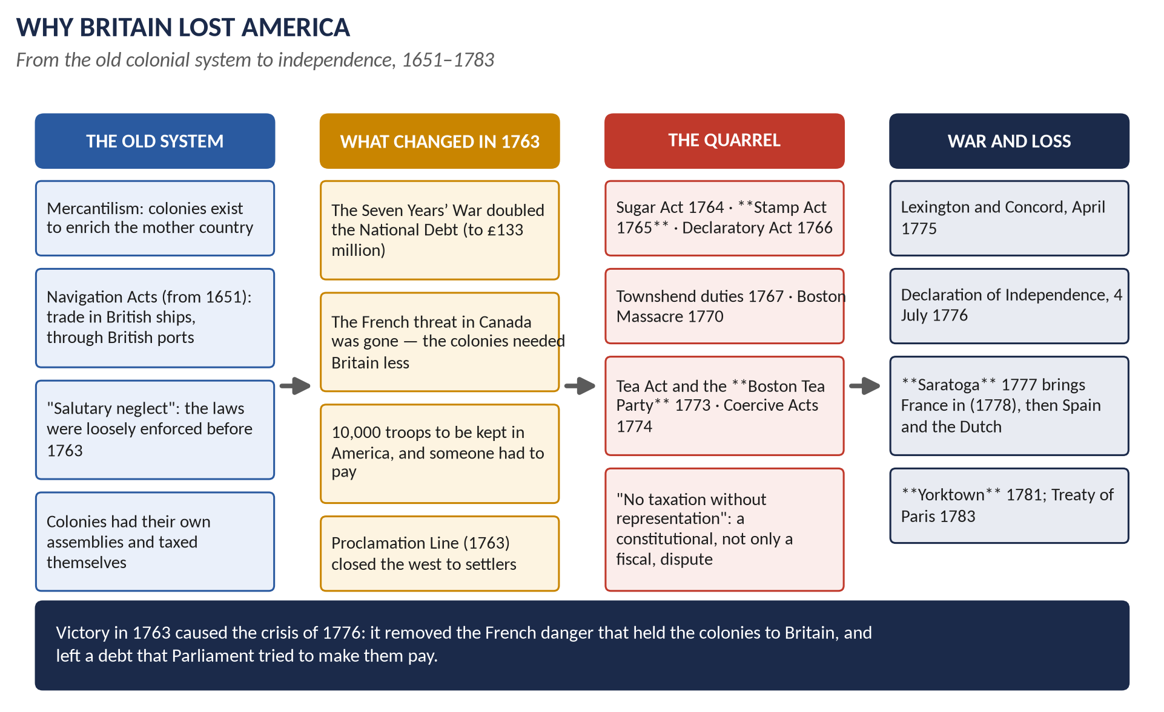
Figure 8 · From the old colonial system to independence: why Britain lost America.

7.1 The causes

(i) The consequences of victory (1763)
1. The French threat was gone. The colonies no longer needed British protection — a point made at the time by the Duke of Bedford.
2. The debt had doubled to about £133 million; interest ate more than half the peacetime budget.
3. A standing army of 10,000 was to remain in America, and Parliament expected the colonies to contribute.
4. The Proclamation Line (1763) barred settlement west of the Appalachians, angering both settlers and land speculators.

(ii) The tax quarrel
Year | Measure and reaction
1764 | Sugar Act: lower molasses duty but enforced — "no taxation without representation" first heard
1765 | Stamp Act: duty on documents, newspapers, cards. Stamp Act Congress; boycotts; Sons of Liberty
1766 | Stamp Act repealed, but the Declaratory Act asserts Parliament's right to bind the colonies "in all cases whatsoever"
1767 | Townshend duties on glass, lead, paint, paper and tea; colonial non-importation
1770 | Duties repealed except tea; the Boston Massacre (five killed)
1773 | Tea Act gives the East India Company a monopoly; the Boston Tea Party, 16 December
1774 | Coercive ("Intolerable") Acts close Boston harbour and alter the Massachusetts charter; Quebec Act extends Quebec to the Ohio; First Continental Congress

(iii) The deeper causes
- Constitutional: who was sovereign? The colonists accepted the King but denied Parliament's right to tax them; Britain could not accept a divided sovereignty. Virtual representation convinced nobody in America.
- Political and social: a century of self-government through assemblies; a literate, prosperous society with its own elites.
- Ideological: the Commonwealth or "country" tradition of English radicalism — fear of standing armies, placemen and corrupt ministers — read in America as a plot against liberty.
- Economic: merchants resented the Navigation Acts and the currency restrictions; but taxation was light and the real quarrel was about rights.

7.2 The war
Year | Events
1775 | Lexington and Concord (19 April); Bunker Hill; Washington takes command
1776 | Paine's Common Sense; Declaration of Independence (4 July); British take New York; Trenton
1777 | Howe takes Philadelphia; Burgoyne surrenders at Saratoga (17 October)
1778 | France allies with the USA; the war becomes global
1779–80 | Spain and the Dutch join; Gibraltar besieged; Charleston falls
1781 | Cornwallis trapped by de Grasse's fleet and Washington: Yorktown, 19 October
1782–83 | North falls; Rodney wins at the Saintes (1782); Treaty of Paris, 3 September 1783

Why Britain lost
1. Distance and geography: 3,000 miles of supply line; no single centre whose capture would end the war.
2. The nature of the enemy: a popular war; militia everywhere; Washington's strategy of survival.
3. Loss of sea control: after France joined, Britain had to defend the Channel, the Caribbean, Gibraltar and India at once.
4. No allies: for the first time in a century Britain fought alone, facing the League of Armed Neutrality.
5. Divided opinion at home: Chatham, Burke, Fox and the City opposed the war.
6. British strategy and command: divided authority, slow communications, and Germain's mismanagement of the 1777 campaign.

7.3 The results — the balance sheet for Britain

The debit side
- Thirteen colonies lost — about a third of the empire by population.
- Prestige: defeat by rebels and by France; Minorca lost; Gibraltar besieged for over three years.
- Debt rose to about £240 million; land tax at 4s in the pound.
- Political crisis: North's fall; the King's personal rule discredited; Ireland won legislative independence (1782) while Britain was distracted.

The credit side
- Trade survived the political break: Anglo-American commerce recovered quickly and by the 1790s exceeded pre-war levels — proving Adam Smith's argument (1776) that trade does not require rule.
- The rest of the empire was kept: Canada, the West Indies, Gibraltar, and above all India.
- Reform at home: economical reform; Pitt the Younger's restoration of the finances after 1783; the India Act (1784).
- A lesson learned: the Constitutional Act for Canada (1791) and, much later, the Durham Report and Dominion status grew out of the realisation that colonies of settlement must govern themselves.
- The "swing to the East": the second British Empire was built in India, the Pacific (Botany Bay, 1788) and later Africa.
WHAT THE EXAMINER HAS ASKED · Where Chapter 7 has been asked
2015 P1 Q5: the American War with its debit and credit side for Britain — answered in T2QA. MCQs: George III was monarch during the war (2024); taxation was the issue that most directly led to it (2025); Lord North was PM at the Declaration (2026); it ended with the Treaty of Paris 1783 (2026).

Part Four — Historians and Quotations

4.1 The historians
Historian | The view to quote
J. H. Plumb, The Growth of Political Stability in England 1675–1725 (1967) | Stability was created, not inherited: Walpole's patronage, the Septennial Act and single-party rule made it.
Lewis Namier, The Structure of Politics at the Accession of George III (1929) | Eighteenth-century politics was about interest, family and patronage, not parties or principles; George III acted constitutionally.
Herbert Butterfield, George III and the Historians (1957) | A defence of ideas and party against Namier's structural account.
John Brewer, The Sinews of Power (1989) | The "fiscal-military state": taxes, credit and administration made Britain a great power.
Linda Colley, Britons (1992) | Protestantism, war with France and empire forged a British identity after 1707.
Bruce Lenman, The Jacobite Risings in Britain (1980) | Jacobitism was a serious political movement, not a romantic lost cause.
Eric Williams, Capitalism and Slavery (1944) | Slavery financed industrialisation; abolition followed West Indian decline.
Seymour Drescher, Econocide (1977) | Abolition was "econocide" — a moral and political choice against economic interest.
Adam Smith, The Wealth of Nations (1776) | The colonial monopoly was a burden: empire cost more than it paid.
P. J. Marshall, The Making and Unmaking of Empires (2005) | The same forces built British power in India and destroyed it in America.

4.2 Lines worth quoting
"Let sleeping dogs lie." — attributed to Walpole on his policy of peace
"They now ring the bells, but they will soon wring their hands." — Walpole, 1739, on the celebrations for war with Spain
"I know that I can save this country and nobody else can." — Pitt the Elder, 1756
"Born and educated in this country, I glory in the name of Briton." — George III, 1760
"The influence of the Crown has increased, is increasing, and ought to be diminished." — Dunning's motion, 6 April 1780
"A wise and salutary neglect." — Burke, Speech on Conciliation with America, 1775
"The people of the colonies are descendants of Englishmen… they are therefore not only devoted to liberty, but to liberty according to English ideas." — Burke, 1775

Part Five — The Examiner's Record
Paper | The question as set | Family | Type
2015 · Q4 · Paper I | Evaluate analytically and critically the role of Walpole as Secretary of State, Prime Minister, party organiser and financier. | Walpole and the Whig oligarchy | Person
2015 · Q5 · Paper I | Shed light on the American War of Independence with special reference to its debit side and credit side for Great Britain. | American War of Independence | Causes / results
2015 · Q8(c) · Paper I | Short note: Jacobite Revolt of Scotland | The Jacobite risings | Short note
2017 · Q2 · Section A | What were the merits and demerits of Whig rule? What led to the downfall of Whig ascendancy? Analyze comprehensively. | Walpole and the Whig oligarchy | Causes / results
2019 · Q3 · Section A | What was the political and constitutional significance of the Hanoverian succession in England? | The Hanoverian succession | Impact / significance
2020 · Q2 · Section A | What are the merits and demerits of the Whig oligarchy? Critically examine the causes of the downfall of Whig ascendancy. | Walpole and the Whig oligarchy | Causes / results
2022 · Q3 · Section A | 'A glorious success until 1761 and then failure.' Do you agree with this estimate of the career of Chatham? | Pitt the Elder (Chatham) | Quotation / claim
2026 · Q2 · Section A | Examine the complex relationships between abolition, imperialism, and economic interests, and argue for or against the notion that Britain's anti-slavery movement was a thinly veiled justification for colonial expansion. | Slavery, abolition and empire | How far / extent

WHAT THE EXAMINER HAS ASKED · The pattern
The Whig oligarchy is the core family — three questions, twice in nearly identical words. Walpole and Chatham are the two men the examiner asks about. The American War has been set once as a balance sheet, and the objective paper keeps returning to it. 2026 opened a new line with abolition and empire. Never yet asked: the Old Colonial System itself, the Jacobite risings as a full question, George III and the King's Friends, and the causes of the American war on their own.

Part Six — The One-Liner Bank
HOW TO USE THIS · How to use the one-liners
Cover the answer (after the arrow) and say it aloud. 118 questions, grouped by chapter. Words in bold are the ones examiners test. These are not past MCQs — they are the facts behind every possible objective question on this topic. (The past MCQs are solved in T2QA.)

One-liners · The Hanoverian succession
1. Who became king on the death of Queen Anne in 1714? → George I, Elector of Hanover.
2. Under which Act did the crown pass to Hanover? → The Act of Settlement, 1701.
3. Who was the Hanoverian heiress named in that Act, who died weeks before Anne? → Sophia, Electress of Hanover.
4. Roughly how many Catholics with better hereditary claims were passed over? → More than fifty.
5. Which Tory Secretary of State fled to the Pretender in 1715? → Bolingbroke (Henry St John).
6. Which Act of 1706 arranged for a smooth transfer of power on Anne's death? → The Regency Act.
7. For how long were the Tories shut out of office after 1714? → Nearly fifty years (until 1760).
8. What was George I's chief foreign interest? → His Electorate of Hanover.
9. Which Act of 1716 extended the life of a Parliament to seven years? → The Septennial Act.
10. What had the maximum life of a Parliament been before 1716? → Three years (Triennial Act, 1694).
11. Why did the Hanoverian succession strengthen the cabinet? → George I's absences and poor English left ministers to meet and decide without him.
12. What was the constitutional basis of George I's title? → An Act of Parliament, not hereditary right.

One-liners · Walpole and the Whig oligarchy
13. In which year did the South Sea Bubble burst? → 1720.
14. What nickname did Walpole earn for shielding ministers and the Crown after the Bubble? → The "Screen-Master General".
15. When did Walpole become First Lord of the Treasury? → 1721.
16. How long was Walpole in office? → Twenty-one years (1721–1742) — the longest in British history.
17. Which two offices did Walpole hold together? → First Lord of the Treasury and Chancellor of the Exchequer.
18. Why did Walpole stay in the House of Commons? → Because the Commons voted the money and held real power.
19. Which queen was Walpole's key ally at court? → Queen Caroline, wife of George II.
20. What phrase summed up Walpole's foreign policy? → "Let sleeping dogs lie" — peace.
21. To what level did Walpole cut the land tax by 1732? → 1s in the pound.
22. What fund did Walpole use to reduce the National Debt? → The sinking fund.
23. Which 1733 proposal did Walpole withdraw after a public outcry? → The excise scheme.
24. What was the slogan against the excise scheme? → "No slavery, no excise, no wooden shoes".
25. What did critics call Walpole's system of patronage? → The "Robinocracy".
26. Which 1728 ballad opera satirised Walpole? → Gay's The Beggar's Opera.
27. Which opposition paper attacked Walpole? → The Craftsman.
28. Which war, forced on Walpole in 1739, began his fall? → The War of Jenkins' Ear (with Spain).
29. What did Walpole say when the bells rang for that war? → "They now ring the bells, but they will soon wring their hands."
30. When and why did Walpole resign? → 1742, when he lost his majority in the Commons.
31. Which house did George II give Walpole in 1735? → 10 Downing Street — as the official residence of the First Lord of the Treasury.
32. Which historian argued Walpole created "political stability"? → J. H. Plumb.
33. Which historian saw 18th-century politics as patronage and interest, not party? → Sir Lewis Namier.
34. What is a placeman? → An MP holding a paid office under the Crown, who therefore voted with the government.
35. What is a rotten borough? → A constituency with very few voters that still returned MPs.
36. Which famous rotten borough had a handful of voters? → Old Sarum.
37. Roughly what share of adult men could vote in England? → About one in five.
38. Which duke was the great election manager of the mid-century? → The Duke of Newcastle.

One-liners · The Jacobites
39. What does "Jacobite" mean and where does the word come from? → A supporter of the exiled Stuarts, from Latin Jacobus — James.
40. Who was the "Old Pretender"? → James Francis Edward Stuart (1688–1766).
41. Who was the "Young Pretender"? → Charles Edward Stuart (1720–88), "Bonnie Prince Charlie".
42. Who led the rising of 1715? → The Earl of Mar.
43. Which indecisive battle was fought in November 1715? → Sheriffmuir.
44. Where did the English Jacobites of 1715 surrender? → Preston.
45. Why did the Fifteen fail? → Poor leadership, no French help (Louis XIV died in 1715) and government control of the Lowlands.
46. Where did Charles Edward raise his standard in August 1745? → Glenfinnan.
47. Which battle did the Jacobites win in September 1745? → Prestonpans.
48. How far south did the Jacobite army reach? → Derby, on 5 December 1745.
49. What was the panic in London called? → "Black Friday".
50. Why did the Jacobites turn back at Derby? → No English rising, no French landing, and three armies converging on about 5,000 men.
51. Which battle did the Jacobites win in January 1746? → Falkirk.
52. Where and when was the Jacobite army destroyed? → Culloden, 16 April 1746.
53. Who commanded the government army at Culloden? → The Duke of Cumberland, later nicknamed "the Butcher".
54. Which Act of 1746 banned Highland dress? → The Act of Proscription.
55. Which Act of 1747 abolished the chiefs' private courts? → The Heritable Jurisdictions Act.
56. Who was the last peer beheaded in Britain (1747)? → Lord Lovat.
57. What was the "primary cause" of the Jacobite risings? → The Stuart dynastic claim — not simply religion, economics or nationalism.

One-liners · The Old Colonial System and slavery
58. What is mercantilism? → The belief that wealth is a fixed stock, so colonies exist to enrich the mother country.
59. What did the Navigation Acts require? → Colonial trade in British ships, with "enumerated" goods shipped through British ports.
60. From what year do the Navigation Acts date? → 1651 (extended 1660, 1663).
61. Name three "enumerated" goods. → Sugar, tobacco, cotton (also indigo, rice, naval stores).
62. What did Burke call the loose enforcement of these laws? → "Salutary neglect".
63. What were the three legs of the triangular trade? → Manufactures to Africa; enslaved people across the Middle Passage; sugar and tobacco home.
64. Roughly how many Africans did British ships carry into slavery? → About 3.1 million.
65. Which port led the British slave trade by the 1750s? → Liverpool.
66. What was the asiento and when was it won? → The contract to supply enslaved Africans to Spanish America, won at Utrecht, 1713.
67. What did Somerset's case (1772) decide? → An enslaved person could not be forcibly removed from England.
68. When was the Abolition Society founded, and by whom? → 1787, by Granville Sharp, Thomas Clarkson and Quakers.
69. Who led the parliamentary campaign against the slave trade? → William Wilberforce.
70. Which formerly enslaved author published his Narrative in 1789? → Olaudah Equiano.
71. When was the slave trade abolished in the British Empire? → 1807.
72. When was slavery itself abolished? → 1833 (taking effect 1834, with apprenticeship until 1838).
73. How much compensation was paid — and to whom? → £20 million, to the slave owners, not the enslaved.
74. Which naval force suppressed the trade after 1807? → The West Africa Squadron.
75. Which 1791–1804 revolution destroyed the richest slave colony? → The Haitian Revolution (Saint-Domingue).
76. Which historian argued abolition followed economic decline? → Eric Williams, Capitalism and Slavery (1944).
77. Which historian replied that abolition was "econocide"? → Seymour Drescher (1977).

One-liners · Chatham and the Seven Years' War
78. What are the dates of the Seven Years' War? → 1756–1763.
79. What is it called in American history? → The French and Indian War.
80. Which island did Britain lose in 1756? → Minorca.
81. Which admiral was shot in 1757 for failing to relieve it? → Admiral Byng.
82. What did Pitt say on taking office? → "I know that I can save this country and nobody else can."
83. Who managed Parliament and finance while Pitt ran the war? → The Duke of Newcastle.
84. Which European ally did Britain subsidise? → Prussia, under Frederick the Great.
85. Which year is called the "Year of Victories"? → 1759.
86. Name three victories of 1759. → Quebec, Minden, Quiberon Bay (also Lagos).
87. Who died taking Quebec, and who died defending it? → Wolfe and Montcalm.
88. Which 1757 battle made the East India Company the power in Bengal? → Plassey.
89. Who commanded at Plassey? → Robert Clive.
90. Which admiral destroyed the French fleet at Quiberon Bay? → Hawke.
91. Which treaty ended the Seven Years' War? → The Treaty of Paris, 1763.
92. Name four territories Britain gained in 1763. → Canada, Florida, Senegal, Grenada (also land east of the Mississippi).
93. Which sugar island did Britain return to France? → Guadeloupe (and Martinique).
94. Why did Pitt resign in 1761? → The cabinet refused to declare war on Spain pre-emptively.
95. What title did Pitt take in 1766? → Earl of Chatham.
96. What was Pitt's popular nickname? → The "Great Commoner".

One-liners · George III and the American war
97. When did George III come to the throne? → 1760, aged 22.
98. What did he say about his birth? → "Born and educated in this country, I glory in the name of Briton."
99. Who were the "King's Friends"? → MPs who supported the King's chosen ministers after 1760.
100. Who was George III's first chief minister, in 1762? → Lord Bute.
101. Which radical journalist was prosecuted over North Briton No. 45? → John Wilkes.
102. Which kind of warrant did the courts declare illegal in the Wilkes case? → The general warrant.
103. For which constituency was Wilkes repeatedly elected and expelled? → Middlesex.
104. Who was prime minister from 1770 to 1782? → Lord North.
105. Which 1763 measure closed the west to colonial settlers? → The Proclamation Line.
106. Which Act of 1765 taxed documents and newspapers in the colonies? → The Stamp Act.
107. Which Act of 1766 asserted Parliament's right to bind the colonies "in all cases whatsoever"? → The Declaratory Act.
108. What was the colonists' slogan? → "No taxation without representation".
109. What was Britain's constitutional reply? → "Virtual representation" — MPs represent the whole empire.
110. When was the Boston Tea Party? → 16 December 1773.
111. What did the colonists call the Coercive Acts of 1774? → The "Intolerable Acts".
112. Where did fighting begin, in April 1775? → Lexington and Concord.
113. When was the Declaration of Independence adopted? → 4 July 1776.
114. Which 1777 battle brought France into the war? → Saratoga.
115. Which powers joined against Britain after 1778? → France (1778), Spain (1779) and the Dutch (1780).
116. Where did Cornwallis surrender, and when? → Yorktown, 19 October 1781.
117. Which treaty recognised American independence? → The Treaty of Paris, 1783.
118. Which 1776 book argued that the colonial monopoly cost more than it paid? → Adam Smith's The Wealth of Nations.

Part Seven — Revision Sheet · Topic 2: Hanoverian Britain, the Whig Oligarchy and the First Empire, 1714–1783
HOW TO USE THIS · How to use this sheet
Complete on its own: it can be read the night before the paper without the rest of the document. It covers syllabus Head II (the Hanoverian era, the Jacobite rebellions, Walpole and the Whig oligarchy, the American War) and Head V (the Old Colonial System). Asked in 2015 (twice, plus a short note), 2017, 2019, 2020, 2022 and 2026.

R2.1 The story in ten lines
1. 1714: Anne dies; George I of Hanover succeeds under the Act of Settlement; the Whigs take office and the Tories are shut out for nearly fifty years.
2. 1715: the Fifteen — Mar's Jacobite rising — fails at Sheriffmuir and Preston; the Septennial Act (1716) gives seven-year parliaments.
3. 1720: the South Sea Bubble bursts; Walpole restores confidence and becomes first minister in 1721.
4. 1721–42: Walpole governs by peace, low taxes and patronage; the excise scheme fails (1733); he is forced into the War of Jenkins' Ear (1739) and falls in 1742.
5. 1745–46: the Forty-Five — Charles Edward reaches Derby (5 December 1745) and is destroyed at Culloden (16 April 1746); the clan system is dismantled.
6. Throughout: the empire grows on mercantilist rules — the Navigation Acts, the sugar colonies and the Atlantic slave trade (about 3.1 million Africans carried).
7. 1756–63: the Seven Years' War. Pitt the Elder subsidises Prussia and strikes at French colonies; 1759 is the Year of Victories (Quebec, Minden, Quiberon Bay); Plassey (1757) wins Bengal.
8. 1763: the Treaty of Paris gives Britain Canada, Florida and dominance in India — and leaves a debt of £133 million.
9. 1760: George III succeeds, ends the Tory proscription, and the Whig oligarchy dissolves into factions; Wilkes raises the cry of liberty.
10. 1765–83: Stamp Act → Boston Tea Party (1773) → Lexington (1775) → Declaration of Independence (4 July 1776) → Saratoga (1777) brings in France → Yorktown (1781) → Treaty of Paris (1783): the thirteen colonies are lost.

R2.2 The Hanoverian succession — political and constitutional significance
- Political: the Whig supremacy (1714–60); the Tories proscribed as Jacobites; politics becomes management by patronage; Jacobitism as the permanent alternative (1715, 1745).
- Constitutional: the crown held by Act of Parliament, so divine right is dead; cabinet government grows in the king's absence; a first minister emerges (Walpole, 1721); ministers must hold the Commons (Walpole resigns 1742); the Act of Settlement ties the monarch to Britain (Anglican; no foreign wars without consent; judges secure).
- Limits: the Crown still chose ministers and controlled patronage — as George III proved after 1760. The change was by convention, not by statute.

R2.3 Walpole in four roles
Role | Achievement | Criticism
Minister of the Crown | Treasury and Exchequer together; kept the confidence of two kings and Queen Caroline | Depended on court favour as much as on Parliament
Prime minister | Stayed in the Commons; enforced cabinet unity; resigned on losing his majority (1742) | Never held or claimed the title; drove out able rivals
Party organiser | Patronage, the Septennial Act, Treasury management of elections | Institutionalised corruption — the "Robinocracy"
Financier | Restored credit after 1720; sinking fund; land tax down to 1s | Withdrew the sound excise scheme (1733) under pressure

R2.4 The Whig oligarchy: merits, demerits, downfall
- Merits: stability after a century of upheaval; peace and trade; the Protestant succession secured; cabinet government develops; practical toleration and a free press.
- Demerits: government by patronage; rotten and pocket boroughs; a closed oligarchy of great families; the Tories proscribed; no reform of Parliament, Ireland, the law or the colonies.
- Downfall: George III (1760) chooses his own ministers and ends the proscription; Bute (1762) breaks the monopoly; the Whigs split into factions; Wilkes and popular radicalism; the American crisis exposes a system built for management, not imagination.
- Historians: Plumb (stability was created by Walpole's system); Namier (interest and patronage, not party); Butterfield (ideas and party mattered).

R2.5 The Jacobites
- The Fifteen: Mar; Sheriffmuir and Preston; failed through poor leadership and no French help.
- The Forty-Five: Glenfinnan (Aug 1745) → Prestonpans → Derby (5 Dec) → Falkirk → Culloden (16 Apr 1746) under Cumberland.
- Why Derby mattered: no English rising, no French landing, three armies converging, only 5,000 men.
- Aftermath: executions; Act of Proscription (1746); heritable jurisdictions abolished (1747); forfeited estates; the clan system ends; Highland regiments later serve the empire.
- Significance: the dynasty made safe; Britain free to fight France overseas.

R2.6 The Old Colonial System, slavery and abolition
- Mercantilism → the Navigation Acts (1651, 1660, 1663): British ships, enumerated goods through British ports, colonial manufacture restricted.
- Salutary neglect before 1763: assemblies taxed themselves, smuggling was normal.
- The triangular trade: about 3.1 million Africans; Liverpool, Bristol, London; the asiento (1713).
- Abolition: Somerset (1772) → Society (1787) → Equiano (1789) → slave trade abolished 1807 → slavery abolished 1833–34 with £20 million compensation to owners.
- The debate: Williams (economic decline caused abolition) v Drescher ("econocide" — a moral choice); resistance by the enslaved (Haiti 1791–1804, Demerara 1823, Jamaica 1831–32) was decisive.
- Abolition and empire: anti-slavery later justified intervention and expansion (Lagos 1861; Brussels Conference 1890) — but abolition came before the new imperialism, so it was a justification used afterwards, not a veil for it.

R2.7 Chatham and the Seven Years' War
- Causes: colonial rivalry in the Ohio valley and India; the Diplomatic Revolution of 1756 (Britain–Prussia, France–Austria); Frederick's invasion of Saxony.
- Pitt's strategy: subsidise Prussia, use the navy, promote by merit, borrow heavily — "America was conquered in Germany".
- The victories: Plassey 1757; Louisbourg 1758; Quebec, Minden, Lagos, Quiberon Bay 1759; Havana and Manila 1762.
- Treaty of Paris 1763: Canada, Florida, Senegal, Caribbean islands, French India reduced; Guadeloupe returned.
- "Glorious success until 1761, then failure": true in outline — he resigned in 1761 over Spain, took a pension and a peerage, and his 1766–68 ministry collapsed — but the same pride and independence produced both the triumph and the fall, and he still carried the repeal of the Stamp Act (1766).

R2.8 Why Britain lost America — and the balance sheet
- Causes: victory in 1763 removed the French threat and left a debt; the Proclamation Line; Stamp Act (1765), Declaratory Act (1766), Townshend duties (1767), Tea Party (1773), Coercive Acts (1774); the constitutional question of sovereignty; a century of self-government.
- Why Britain lost: distance; a popular war with no decisive centre; loss of sea control after France joined (1778); no allies; divided opinion at home; poor command.
- Debit: thirteen colonies; prestige; Minorca; debt to about £240 million; North's fall; Irish legislative independence (1782).
- Credit: trade recovered and grew (Adam Smith vindicated); Canada, the West Indies, Gibraltar and India kept; economical reform and Pitt the Younger's revival; the lesson that colonies of settlement must govern themselves; the "swing to the East".

R2.9 Ten dates to write in every answer
1714 George I · 1715 the Fifteen · 1716 Septennial Act · 1720 South Sea Bubble · 1721–42 Walpole · 1745–46 the Forty-Five and Culloden · 1756–63 Seven Years' War · 1757 Plassey · 1759 Year of Victories · 1763 Treaty of Paris and Proclamation Line · 1765 Stamp Act · 1773 Boston Tea Party · 1776 Declaration of Independence · 1781 Yorktown · 1783 Treaty of Paris · 1807 slave trade abolished.
VERDICT · The whole topic in one sentence
Between 1714 and 1783 a foreign dynasty and a single party gave Britain the political stability it had lacked, and that stability — with sea power, credit and the slave-worked colonies — built the greatest empire in the world; but the victory of 1763 destroyed the fear that bound the American colonies to Britain, and the attempt to tax them lost the first empire in 1783.

